**Testing table**

**&**

**Program ideal state**

**Testing table for screen3 “Add New student data”**

|  |  |  |  |  |
| --- | --- | --- | --- | --- |
| Input | Requisite output | Actual output | conformance to expectation | Solution |
| Put student name: 797 | “Please put the right name” | “Please put the right name” | Work |  |
| Put student name: Sonny | Write the student name: Sonny into CSV file | Write the student name: Sonny into CSV file | Work |  |
| Choose the combo box subject | Write the subject name into csv file | Write the subject name into csv file | Work |  |
| Put student name: Sonny and choose six same subjects | “You choose two same subjects please change “ | Write all data into csv file | Not work | Add rule for combo box each text in combo box cannot be the same(Still not fix now) |

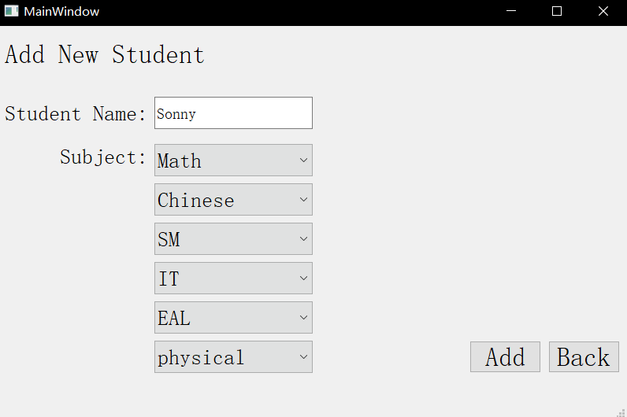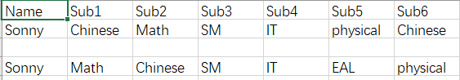

**Testing table for screen4 “Add New Subject”**

|  |  |  |  |  |
| --- | --- | --- | --- | --- |
| Input | Requisite output | Actual output | conformance to expectation | Solution |
| Subject name:789 | “Please write the right subject name” | “Please write the right subject name” | Work |  |
| Subject name: Japanese | Write the subject into csv file | Write the subject into csv file | Work |  |
| Subject name: Japanese again | “You already write this subject into csv file | Write the subject into csv file | Not work | Add a rule when enter the new subject name test weather the subject have been add in before (Still not fix now) |

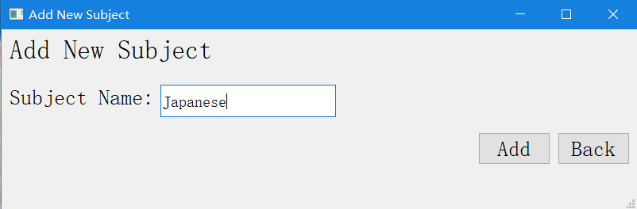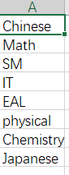

**Testing table for screen5 “Create a new timetable”**

|  |  |  |  |  |
| --- | --- | --- | --- | --- |
| Input | Requisite output | Actual output | conformance to expectation | Solution |
| Select two files | Print the name and position of the file in the program | Print the name and position of the file in the program | Work |  |

